# **Updating Search Index for Quercus Support Resources**

## Screen Recording

[ITS ACT Support > Documentation and Resources > Files > Quercus Support Resources Search](https://utoronto.sharepoint.com/sites/001T_ITSACTSupport/Shared%20Documents/Documentation%20and%20Resources/Quercus%20Support%20Resources%20Search/Update%20QSR%20Search.mp4)

## Instructions

1. Using Chrome, sign into Quercus
2. In ACT Support Team, go to Documentation and Resources > Files > Quercus Support Resources Search

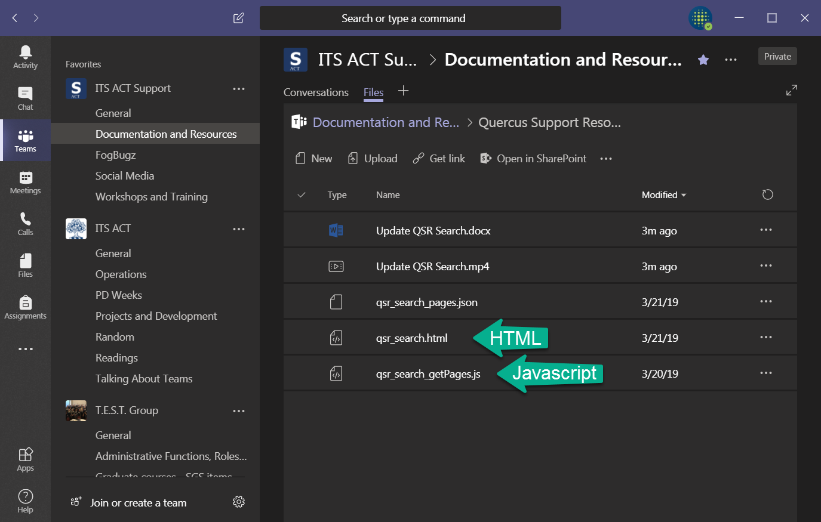

1. Open the **qsr_search_getPages.js** file in NotePad or TextEdit (or a code editor)
2. Copy everything from the **.js** file

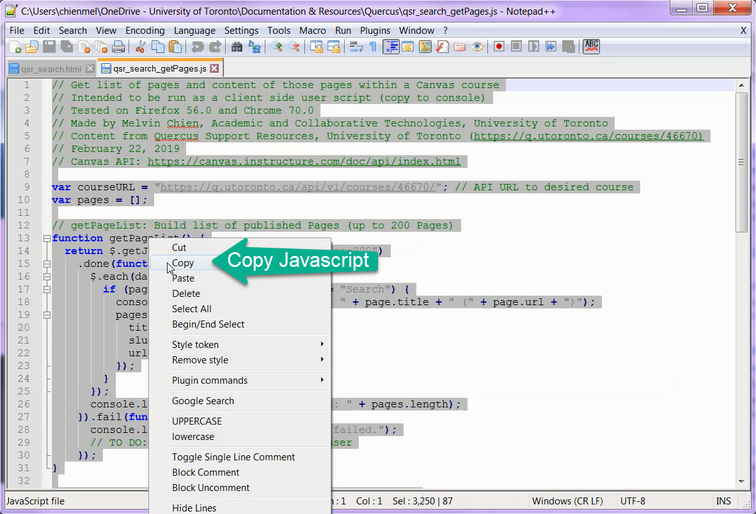

1. In Chrome, open the Developer Tools Console (F12)
2. Past in code and press Enter
3. From the output, make sure the second last line says “SUCCESS: ….” (other 404 errors can be ignored)
4. A **qsr_search_pages.json** file will be automatically downloaded to your computer

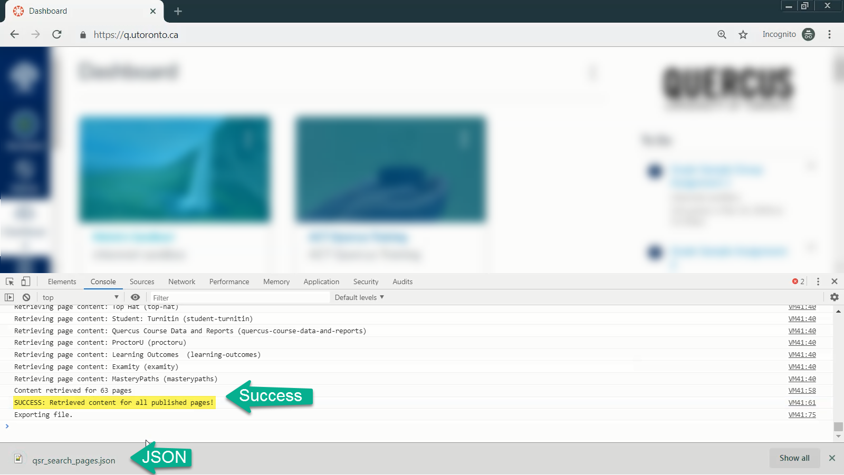

1. Open the **.json** file in NotePad or TextEdit (or a code editor) and copy the entire file
2. Open **qsr_search.html** in NotePad or TextEdit (or a code editor) and look for “**var pages = [**“
3. Select the text starting from the opening square bracket ([) until the closing square bracket (]), but before the semicolon (;)

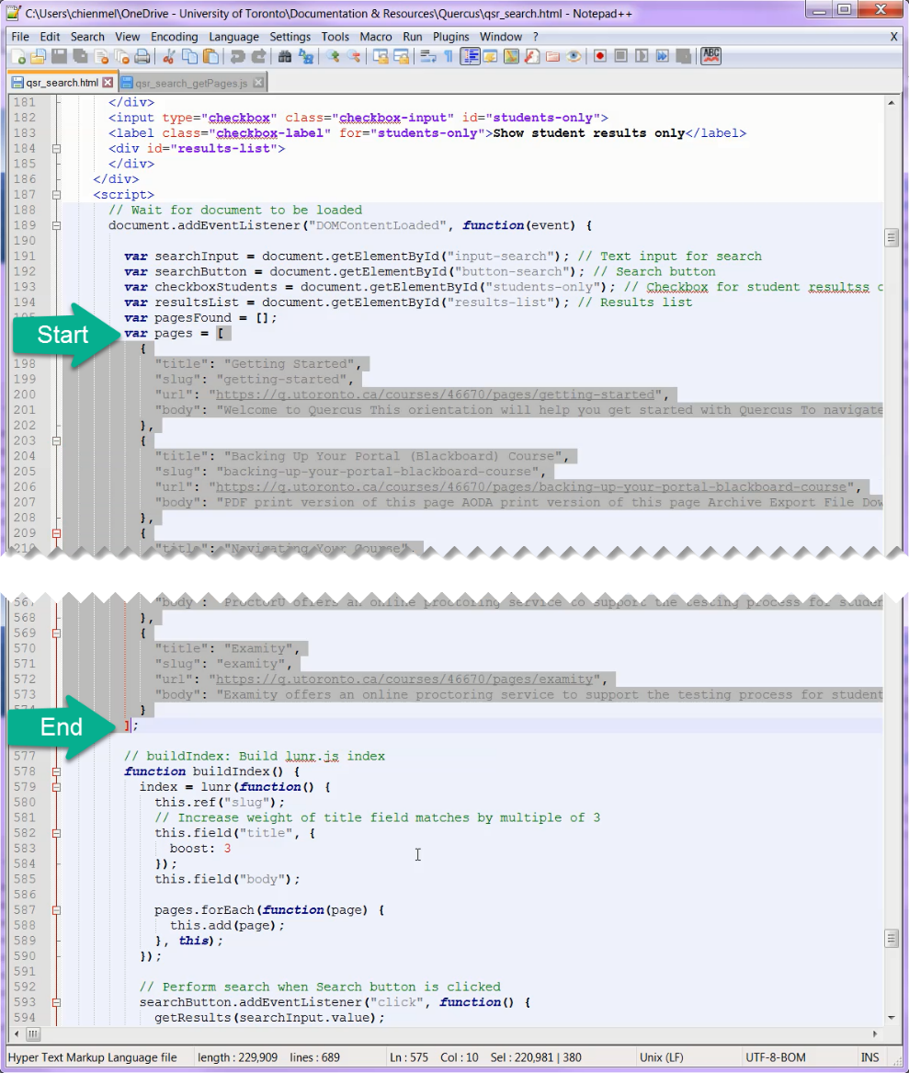

1. Paste the copied text from the .json file and optionally fix the indenting (not necessary)
2. Save the .json file
3. In Quercus, go to the Quercus Support Resources course
4. Go to Files and upload the newly edited **qsr_search.html** file, making sure the existing file is **replaced**

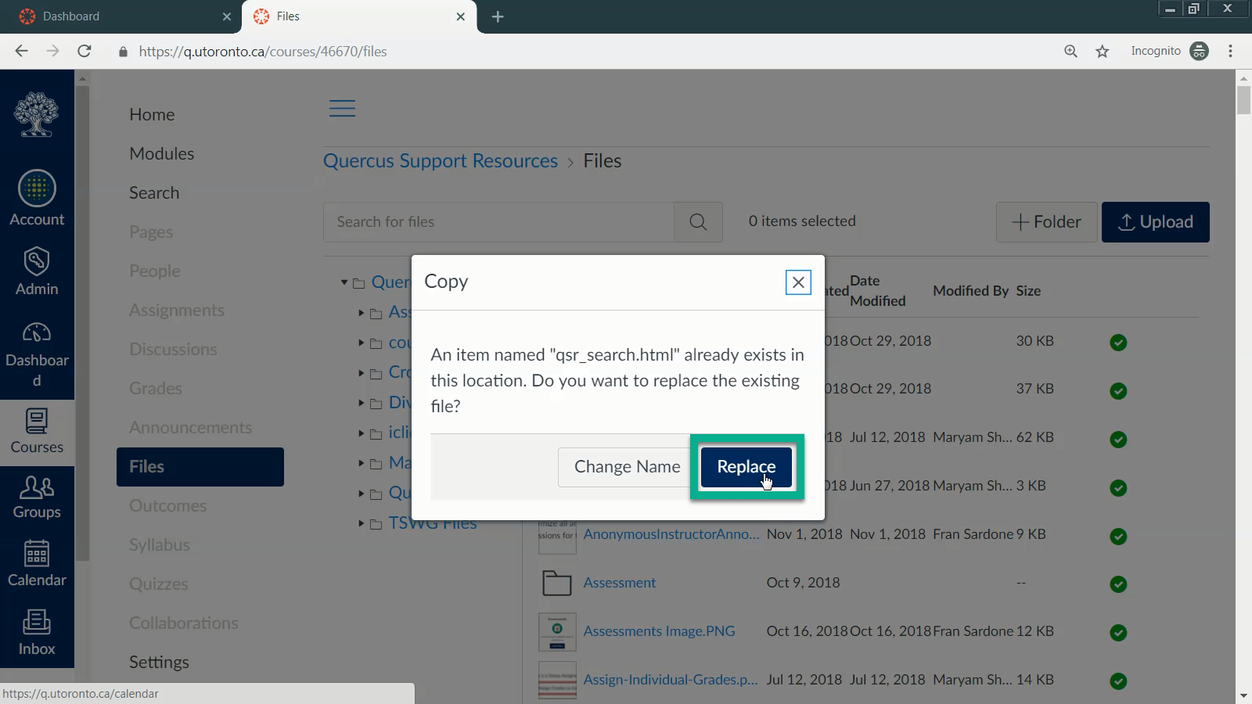

1. Test the search functionality